**Project 1: Service Website**

**SEG3125 – Analysis and Design of User Interfaces**

**Summer 2023**

**University of Ottawa**

**Professor:**

**Colby Todd: 300241178**

**Submission Date: June 11, 2023**

# Experience

Before this project I had very little experience with JavaScript. In order to learn more about JavaScript I followed tutorials like this one <https://websitesetup.org/bootstrap-tutorial-for-beginners/> and used the Bootstrap documentation <https://getbootstrap.com/docs/5.0/getting-started/introduction/>. I also used a lot of googling and ChatGPT to help me implement functionalities I wanted.

# Service Type

The service type I choose for my business is a massage clinic. I chose a massage clinic because it fit the idea and structure I wanted for my website. I also wanted my service to be one that provides the service directly to the user instead of something such as fixing a bike.

# Inspiration

For inspiration I used two other massage clinic websites:

* <https://kneadedtouch.ca/>
* <https://alignyourbody.com/home>

# Mockups

This will be the first page seen when entering the website. The slideshow will contain links to other pages on the website with a description and image as the background. I have a link to booking right on the front page since the primary goal of this website is to get users to book massages. I also put a contact us on the bottom of the home page to allow users to ask any questions or concerns they may have. To navigate to the other pages, users will either use the slideshow, the buttons below book online or the menu bar at the top. After the home page, if users would like more information, we expect them to navigate either to staff, services or locations.

This page will give information for the user on the staff members at each location. It will give the staff members name qualifications, a description of them and what services they provide. This will help the user choose the staff member they would like when booking their appointment. After this page we expect them to either book an appointment, look at all services that are provided or look at the locations. Full page is show below:

This page gives information on the services provided. It shows the prices per hour for each type of service and gives a description of the service. This will provide the user with more information for their booking. After this page the user will either navigate to book an appointment, or get more information from the other staff and location pages.

This page gives information on the locations, hours, address, and phone # that an appointment can be booked at. After this page, users will either navigate to book an appointment or get more information from the other pages.

On this page users will book an appointment using the information from the other pages. They will have to put their name and email address in, then select the service, location, and expert from drop down menus. Then they will use the calendar to choose a date and time available and press the book button to confirm their order. This will send them to the booking confirmation page.

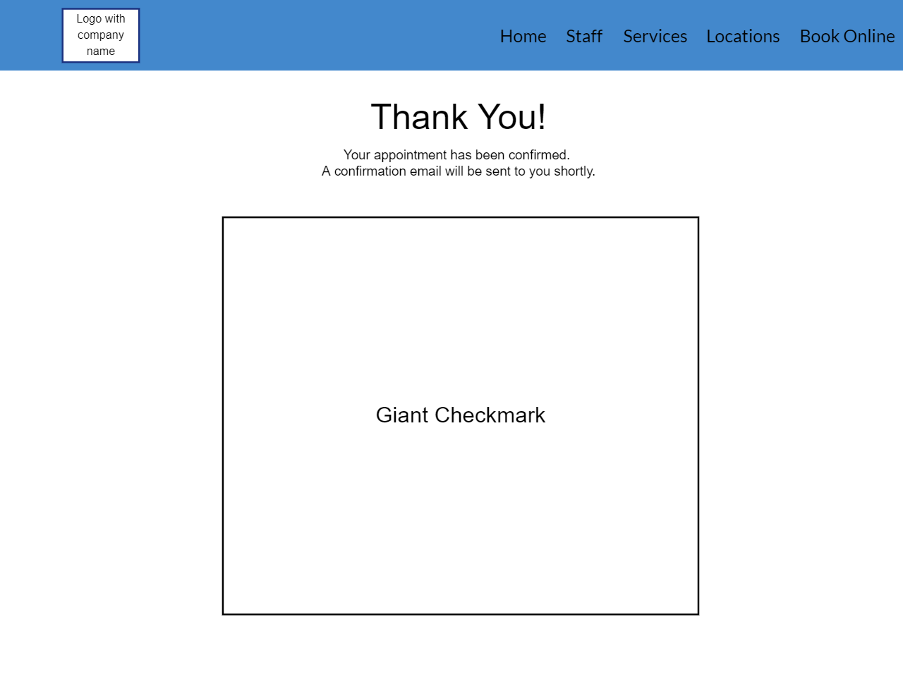

This page will let the user know that their appointment has been confirmed. This is the final page we expect the user to visit.

# UI Elements from Mockups

Two elements from my original mockup that I kept after receiving feedback were the contact us on the home page and my navigation bar. I received feedback from my peers that both these elements looked good and gave the webpage a professional look.

Two elements I changed were the layout of the staff page and changed from three maps to one map on the locations page. I received a lot of feedback on the staff page having a bad layout and that I should have each staff member per location in a row instead of column. I felt that having three maps took to much space, so I condensed them into one larger map.

# Personas

For my personas I chose Jon Shier and Oyama Mahiro.

Jon Shier is in a relationship, a young adult, and a university student. He has very little knowledge of massages and would like to be able to buy a gift card for his significant other. I chose Jon Shier since I thought it would be a great idea to allow users to buy a gift card since it’s a very common and easy gift to give.

Oyama Mahiro is a 20-year-old male who is lazy with no income. He is very comfortable with technology and is a loyal customer. He would like to be able to see a video on how the service works instead of being forced to read and see photos. I chose Oyama Mahiro since I thought adding a video demonstration of the service is a great idea especially since my service will be physically performed on the client.

# UI

<https://colbytodd.github.io/massagewebsite/index.html>

# Code

<https://github.com/ColbyTodd/massagewebsite>

# UI Elements from Class

On my booking page, I used dropdown elements for the service, location, and expert since the valid inputs for these elements are predefined. This allows the user to see their choices ahead of time and not be stuck guessing what inputs are valid.

On my booking page, I also have my dropdown elements require you to pick your location before being allowed to choose your expert. The list of experts’ changes based on the location chosen. I went with this way over having expert be chosen first since most users are going to chose based off of location over expert.

The colours I choose for my website are a relaxed, cool, pastel shades of blue. I got them from here <https://www.color-hex.com/color-palette/23522>. I chose these colours since I want users to be relaxed when visiting my website while still having a professional look.

For fonts, I kept the default Boostrap font for most text since it has a nice professional look and is easy to read. For fonts on my slideshow, I used gobold for the main text since it is a nice large block font that is easy to read and still looks professional. I also used amore mio for the company name font since it’s a fancier font that is relaxing and fun.

# Appendix

## Clipper Cutz

### 1.

I like the book now button being very obvious and a different colour than all the other elements while still fitting the colour scheme. It draws attention to it right away. The book now page is good, the elements with drop down lists are well chosen. I like the layout of the expert page with the circles for expert photos with their name and description right below.

### 2.

For your experts, location, pricing and services page, it would look better if the block full of info was either centered or goes all the way to the edge of the logo. It would be better if instead of being stuck choosing a date for the calendar and not knowing if it's available or not, the calendar would black out dates and times that are full. For the services page, the title of the service should be shown in a larger font on top of the description, there should also be a description of each service shown on the pricing page. I'd also like if the pricing page is shown before the services page.

### 3.

a. The landing page shows the business name and type. The nav bar allows the user to access the information they would like or the user can scroll down to see information.

b. Location page shows the address, phone numbers and hours.

c. Services are shown in the services page and pricing is shown in the pricing page

d. The experts are all shown in the experts page

e. and f. Appointment booking is done on the booking page, contains all required elements

g. Booking confirmation is shown on the confirmation page

### 4.

Karen complains about everything, she is never satisfied and will always fight to get what she wants. Karen takes her son to this barbershop. She uses this website to book appointments for him. She would like to be able to contact the company through the website to leave her complaints and ask questions.

## Technology Repair Service

### 1.

I like the way the services page is done with the cards, it looks really good. Doing the meet the team section with a slideshow looks really good. The appointment booking page is great and contains all the required information. I like the rounded edges on all the cards.

### 2.

The home page would look better with less whitespace between the navigation bar and the company name block. The location page looks good, but having an image of a map with the location could be useful as well. Reviews section is a good touch, however there should be a way for a user to leave a review and the corners should probably be rounded to be consistent with the other elements of the website. The "Select a time to come in at" is unnecessary on the book an appointment section.

### 3.

a. Business name and type shown immediately when entering the website.

The nav bar or scrolling down allows the user to:

b. get to the location page to see address, phone number and hours.

c. get to the service page to see cards with service names that can be flipped to find out their description and costs.

d. get to the team section to see all members of the team by going through the slideshow.

e. and f. get to the appointment page where all required elements are present.

g. After submit the booking information, the booking confirmation pop-up is shown.

### 4.

John is very impatient and hates wasting time. At all times he would like to be doing something productive and moving around. He is very clumsy and breaks his devices often. He will be coming here often to fix his devices. John would like to be able to know ahead of time an estimate of how long it will take to fix his broken device. He'd prefer if he can get this information before booking an appointment that way he can plan ahead.

## To The Top

### 1.

I like the booking being shown immediately on the home page, draws users to it right away. The find a coach page looks great and is well organized. Same with the games page and does a good job at being consistent with the rest of the website.

### 2.

The navigation bar could be a bit smaller as it currently takes up a lot of screen space. The calendar could be a bit larger on the booking page as it is currently a bit hard to see. Price and length not required in the about us section as it is shown in the find a coach section, could have a description of the company and what they do there instead. Overall the website could use a bit more whitespace, it feels a little cluttered currently.

### 3.

a. Business name shown immediately, type not shown explicitly but is obvious while navigating the website, could explain more in the about us section.

Navigation bar allows the user to swap between pages.

b. Address, phone number and "hours" are shown on the about us page.

c. Services provided and descriptions are shown on the coaching services page. Pricing is shown on the find a coach page.

d. Service experts and what they do are shown on the find a coach page.

e. and f. Book a session page contains all the required elements

g. Booking confirmation page gives the user a confirmation once the booking is done.

### 4.

Gaben is a professional gamer who is a natural leader. He loves to share his knowledge with others and is very patient. He would like to become a esports coach. He would like to be able to register as a coach.

## Bakery

### 1.

The contact us page is organized nicely. I like the choice of photos and colours. The cart was a good addition to the confirm order page. I like the blocks on the product page. Having links on the home page to the products is a smart addition, leads users to start looking at the products right away.

### 2.

The block on the home page could look a bit better if it was a bit less opaque. I think it would look a bit better if the add button wasn't next to the price, maybe put it below the image and name of the product. The contact us page should also have the address written down near the map. A home button would be a nice addition to the navigation bar. The product page could use some more whitespace between the edge and the titles. Showing a cart icon on the navigation bar with the number of items in it would be a good addition. Users might never see the pâtissiers at the bottom of the home page. It would be good to put them on their own page.

### 3.

a. Shown on the home page

b. Shown in the contact us page.

c. Shown on the product page.

d. Shown on the home page.

e. and f. Done on the order page.

g. Missing

### 4.

Marjorie is a 45 year old party planner who loves to order custom items. She likes getting cakes exactly how she pictures them and is easily displeased. She demands perfection. She loves to come to this website to get cakes for her parties. She would love to be able to checkout a custom cake, bread or patisserie.